
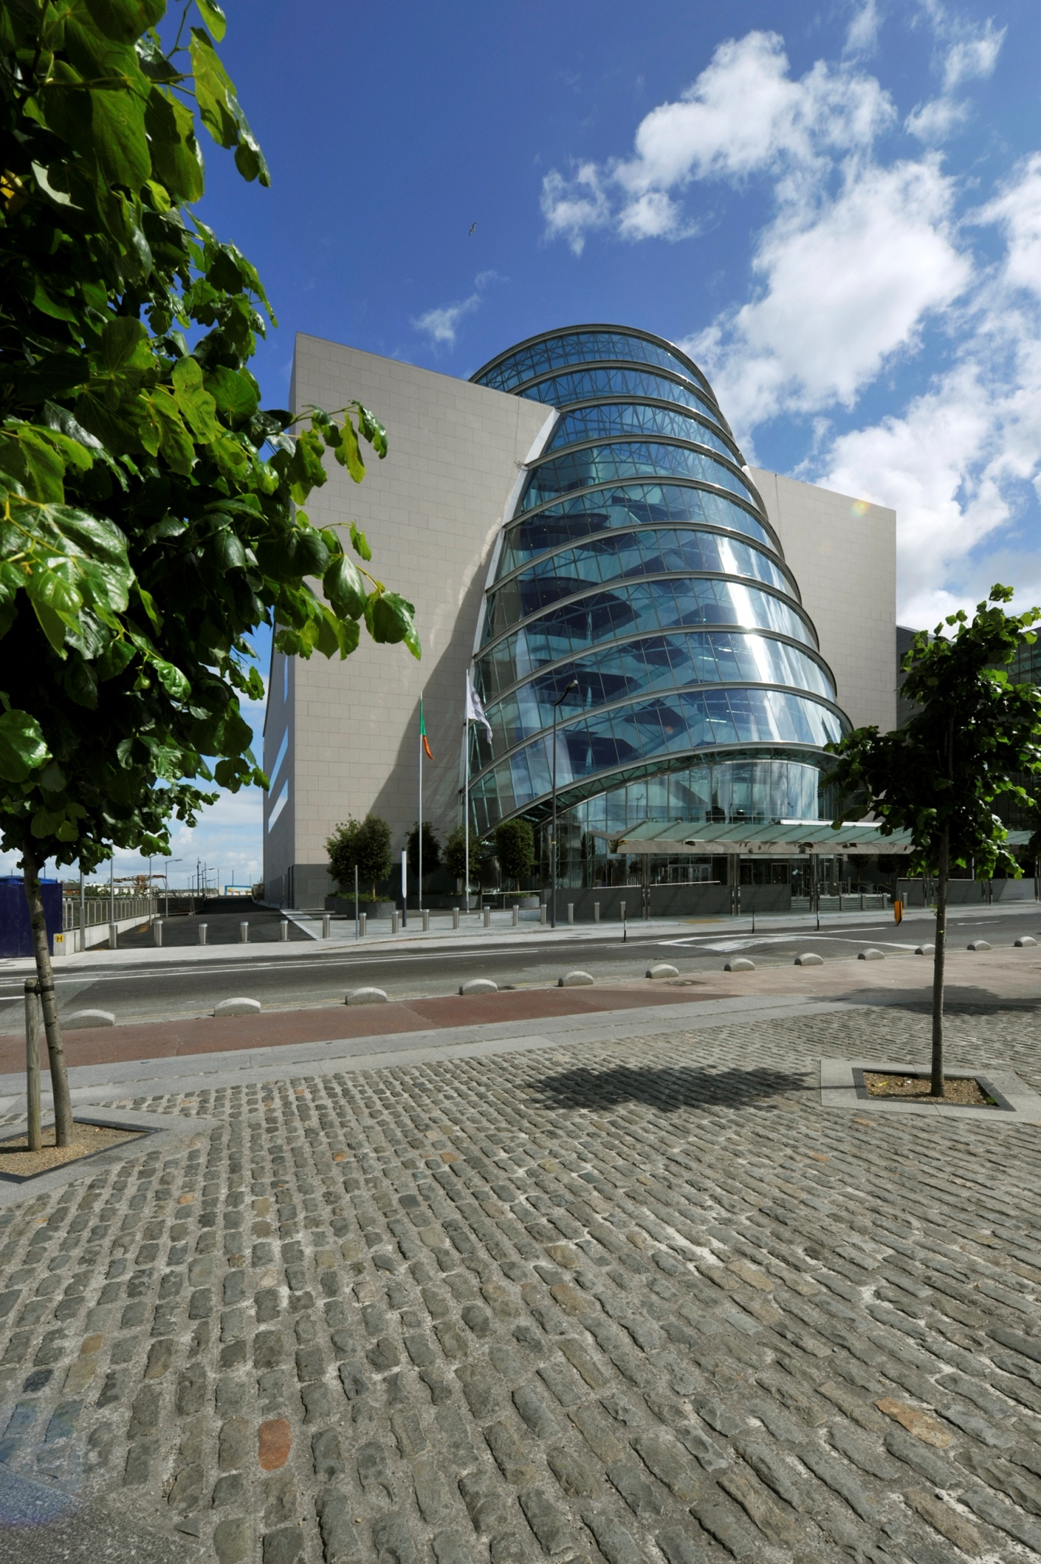

Emergency Evacuation Strategy for Event Organisers

Table of Contents:

1 Emergency Procedures 3
2 Fire Event 3
2.1 Fire Alarm System 3
2.2 On discovery of a fire 4
2.3 Fire Evacuation Procedure 4
2.4 Fire Event – Emergency Response Procedures 5
2.5 Fire Appliances 6
2.6 Occupants with Special Needs 7
2.6.1 Wheelchair users and people with impaired mobility 7
2.6.2 Visitors with impaired vision 8
2.6.3 Hearing Disability 9.
2.6.4 Refuge Areas 9
3 Bomb Incident 10
4 Suspect Package Incident 10
5 Appendix One: Emergency Evacuation Routes 11
6 Assembly Point Location 12-13.

Emergency Procedures

There are a number of emergency procedures at The CCD, of which show organisers should be aware. Organisers are also asked to check for Suspect Package / Vehicle both morning and evening and to ensure that their briefcases and bags are kept safely locked away at all times to prevent causing unnecessary concern. Ensure that all your staff are briefed on these procedures.

Fire Event

In the interest of your own and your colleagues’ safety it is essential that everyone is aware of the location and purpose of fire appliances and the procedures to be followed in the event of an emergency at The Convention Centre Dublin.
The objective and outcome of the building’s fire alarm and evacuation strategy is to ensure that for a fire event the building’s occupants will receive a warning of the fire event and will be able to reach a place of ultimate safety external to the building, within a time period, before exits routes may become untenable, as a result of the effects of the fire event.

Fire Alarm System

An automatic fire detection and warning system (smoke / heat detection); together with an automatic fire suppression system is installed throughout the venue.
The fire alarm will be received in the Security Control Room in one of four ways:
- Smoke or heat detector
- Sprinkler activation
- Break glass point, or
- By phone, using the emergency number ext. 4999 (01 818 4999)

The Security Control Room, which, is staffed 24 hours a day in The CCD, will be the Control Point in any incident or emergency. Internal Telephone number is as follows:
- Security Control Room – ext. 4999 (01 818 4999)
The Security Control Room will be responsible for alerting the Emergency Response Team and summoning the relevant Emergency Services.

On discovery of a fire

- If you discover a fire, or a fire is reported to you, Raise the Alarm immediately by activating a manual break glass point
- Please note that the Voice Activation Alarm will not sound automatically when a manual break glass point is activated – a signal is sent to the fire alarm panel in the Security Control Room.
- Notify a member of The CCD staff of a fire as soon as possible, giving the following information:
    - Exact location of incident
    - Your name
- Initiate the evacuation of visitors and staff away from the fire
- Leave the area and close all doors behind you.
- Use fire exits – do not use lifts unless under the control of appropriately trained staff / or Dublin City Council Fire Brigade.
- Do not attempt to retrieve personal belongings from cloakrooms, offices or other areas.
- Do not run in any areas, as this could be misinterpreted and cause panic.
- Do not re-enter the zone under any circumstances unless the all-clear has been given by the Dublin City Council Fire Brigade.

Fire Evacuation Procedure
The building complex evacuation philosophy is “simultaneous total evacuation”.
The designated category of simultaneous evacuation is “two staged evacuation” – i.e. there is an investigation period undertaken by designated staff before any fire alarm sounders / voice evacuation directions are activated. The basic system operating principles are following the activation of a single fire detector device:
- An initial alert signal will be given – buzzer at Security Control Room fire alarm panel and repeater panels.
- A staff investigation period will then follow
- The fire alarm systems sounders, strobe flashing / voice evacuation directions will be broadcast where:
  - A fire event is confirmed – through staff investigation procedures.
  - The agreed time period for staff investigation of the fire alarm event lapses – without the fire alarm having been cancelled; or
  - A second detector device is activated during the investigation period.

Fire Event – Emergency Response Procedures

Where a fire event is confirmed and is not capable of being brought quickly under control, the building must be evacuated immediately in a well managed and orderly manner.
The investigation of a fire and the management of that event and escalating actions will be the responsibility of The CCD Security Control Room Supervisor until the Dublin City Council Fire Brigade arrives and take effective and strategic command of the situation.

Evacuation:
In the event the building is to be evacuated, the following message will be communicated over the voice activation system. Strobe lights will also activate.

Ladies and Gentlemen. Please may I have your attention. A fire has been reported in the building. Please leave the building immediately, by the nearest exit. Do not use the lifts.

On hearing this message or seeing the strobe lights, all occupants must proceed without delay to the nearest exit. In no circumstances should occupants return to collect personal belongings.

All occupants must adhere to any instructions provided by The CCD Security personnel, The CCD Hosts and the designated Fire Marshals, who will be recognisable as they will be wearing a high visibility jacket.

Assembly Point:
Proceed to the assembly point which is located along the river at North Wall Quay. There will be two individuals (holding STOP signs and wearing high vis vests) standing on the road stopping traffic in order to ensure a safe crossing. Cross the road in between these two individuals and proceed to the Visitor Assembly Point.

It is the responsibility of the Event Organiser to account for all contractors and employees present at the event and report to the Assembly Point Marshall. The Event Organiser will have a registered list of attendees and/or delegates available if requested by Dublin City Fire Brigade.

Return to the Venue:

It is important that once the building evacuation has commenced for people not to attempt to re-enter the building; until the Dublin City Council Fire Brigade or the Assembly Point Marshal has given direction on when it is safe to do so.

Fire Appliances

The location of the Stairs, Fire Extinguishers and Refuge Points are indicated on the attached floor plans.
You are advised to study these plans with regard to the locations of exit staircases (Appendix One).

As part of the event process, each Event Organiser is required to complete a Fire Risk Assessment identifying if the fire load in the building is increased due to the presence of the fixtures/fittings or activities associated with their event. Additional fire extinguishers are available should the venue see it as necessary during events.

Different colours in extinguisher labels indicate different uses.
Fire Fighting Equipment | Colour | Use On
Foam | CREAM | Combustible materials,  Paper, Wood, Upholstery, Oil Fires.
CO2 | BLACK | Electrical Wiring, Machines, Flammable Liquids.
Water | RED | Paper, Wood, Textiles.
Dry Powder | BLUE | Petrols, Paints, Gases & Oils

Fire Blankets
There are fire blankets installed at the tea station areas and kitchens. To use a fire blanket, simply pull it from its enclosure and place it over the fire. Full instructions for its use are printed on the front of the enclosure.
Stairs
There are six sets of stairs located at each corner of the building; 4 x sets Front of House, 2 x sets Back of House. You are advised to familiarise yourself with the location of the stairs within the building.

Lifts
During building evacuation designated evacuation lifts are only to be used under the direction of either appropriately trained staff or under the supervision of the Dublin Fire Brigade.
- P1 (Front of House West side), P4 (Front of House East side) & P5 (Back of House West Side) – Fire Fighting lifts
- P2 (Front of House West side) & P3 (Front of House East side) – Evacuation lifts
Under no circumstances are lifts to be operated by untrained personnel during an emergency evacuation.

Occupants with Special Needs

At no time should visitors or staff with disabilities be left to fend for themselves, during a fire alert / building evacuation.
There are three main stages in assisting people with disabilities:
- Identify those who may need special assistance in an emergency
- Assist those with disabilities to refuge areas
- Evacuate from refuge areas to ground level final exits using evacuation lifts or evacuation chairs within protected stairways.

Some disabilities may not always be obvious i.e. people who have had strokes or heart attacks or who have impaired sight or hearing. It is not only staff and visitors with permanent disabilities who may require special assistance; but also staff and visitors with short term needs i.e. women in the later stages of pregnancy or staff and visitors with broken limbs in plaster etc.

Wheelchair users and people with impaired mobility

It should not be presumed that only people in wheelchairs are viewed to have mobility impairments – this category includes people who can use stairs but might not be able to reach protected exit routes in normal escape times without some aided assistance.
Equally presumptions on the abilities of wheelchair users and their ability to safely leave a building should not be made.
Except at ground level where staff and visitors may be evacuated directly to the outside of the building – wheelchair users and people with impaired mobility should initially be assisted by staff to the main refuge areas.
A member of staff should wait in the refuge with the disabled person(s) until a trained member of The CCD staff or Dublin City Council Fire Brigade arrives to continue the evacuation from the building.
Evacuation from the refuge areas by trained CCD staff will be undertaken as either:
- A stairway carry down procedure by appropriately trained staff and numbers of same using evacuation chairs – noting that it would be important for the trained staff to understand and special or limiting factors which may require an alternative approach to carry down evacuation e.g. person with severe spinal disability
- Evacuation lift exiting from the refuge by trained CCD staff.

Visitors with impaired vision

People with a visual disability will usually require the assistance of one person. On stairways, the helper should lead with the visually impaired persons hand on their shoulder. On level surfaces they should take the helper’s arm and follow them. Visually impaired persons with guide dogs should be advised to hold their dog by the lead and not the harness.
In the event of a fire event, able bodied staff should be vigilant for any visitors / staff with a sight impairment and ensure that they are directed to the nearest available exit route.
Except at ground level where staff and visitors may be evacuated directly to the outside of the building – wheelchair users and people with impaired mobility should initially be assisted by staff to the main refuge areas.
A member of staff should wait in the refuge with the disabled person(s) until a trained member of CCD staff or Dublin City Council Fire Brigade arrives to continue the evacuation from the building.
Evacuation from the refuge areas by the trained CCD staff will be undertaken as either:
- A stairway carry down procedure by appropriately trained staff and numbers of same using evacuation chairs – noting that it would be important for the trained staff to understand and special or limiting factors which may require an alternative approach to carry down evacuation e.g. person with severe spinal disability
- Evacuation lift exiting from the refuge by trained CCD staff.

Visitors with impaired hearing
In the event of an evacuation staff should be vigilant for any visitors with a hearing impairment and ensure they are assisted/directed towards the nearest available exit.

Refuge Areas
- A wheelchair refuge area is provided for each protected stairway facilitating egress from each storey.
- Each refuge is provided with an area accessible for a wheelchair in which a wheelchair bound person can wait for assistance to evacuate the building.
- Where the refuge is within a protected stair, protected lobby, or protected corridor, the wheelchair space does not reduce the required clear exit width; nor obstruct the main flow of people exiting the building.
- The refuge areas are provided with independent two way communication for a person(s) to contact management / be contacted by management in accordance with the recommendations of BS5588 Part 12 (now superseded by BS9999).

Bomb Incident

Dealing with a bomb incident

Immediately upon receipt of a warning, the recipient should notify the Security Control Room on the internal phone system dialling 4999, passing on all relevant information.

It is important that the receiver of the original verbal information asks two important questions:
- Where has the device been placed?
- When will it go off?

This information will help to decide whether all or part of the building is to be evacuated, or if there is time to carry out a search prior to the deadline set.
The Security Supervisor or their designee will decide if the Gardaí are to be called. When they attend, they will, if necessary, alert the Bomb Squad and request their attendance. By this time the evacuation procedure will have been instigated.

Suspect Package Incident

- On the discovery of a suspect package, it must not be interfered with, moved, covered up or touched but must be left for visual examination by experts.
- Do not shake or empty the contents of any suspicious envelopes or packages.
- Place the envelope or package in a plastic bag or some other type of container to prevent leakage of contents.
- If a container is not available cover the envelope or package with anything e.g. clothing / paper / lid of rubbish bin.
- Leave the room, close the door and call the Security Control Room on internal ext. 4999 or 01 818 4999.
- Wash your hands.
- The Security Supervisor or their designee will decide if the Gardaí are to be called. When they attend, they will, if necessary, alert the Bomb Squad and request their attendance. By this time the evacuation procedure should have been instigated.

Appendix One: Emergency Evacuation Routes

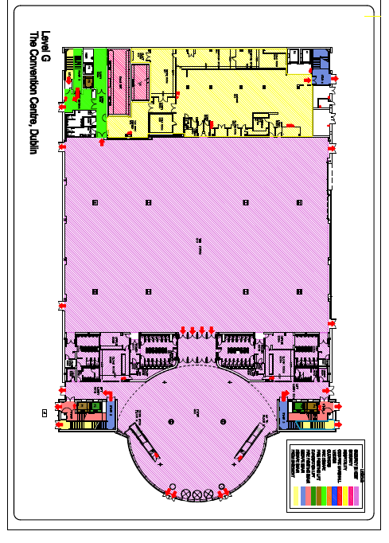

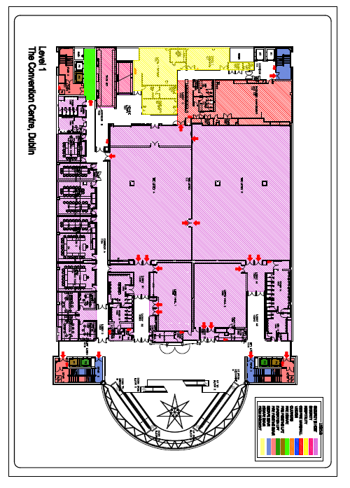

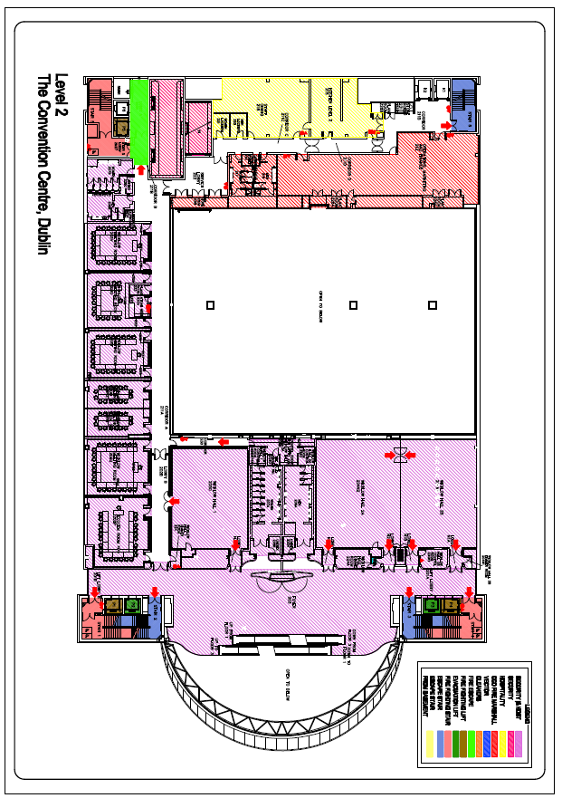

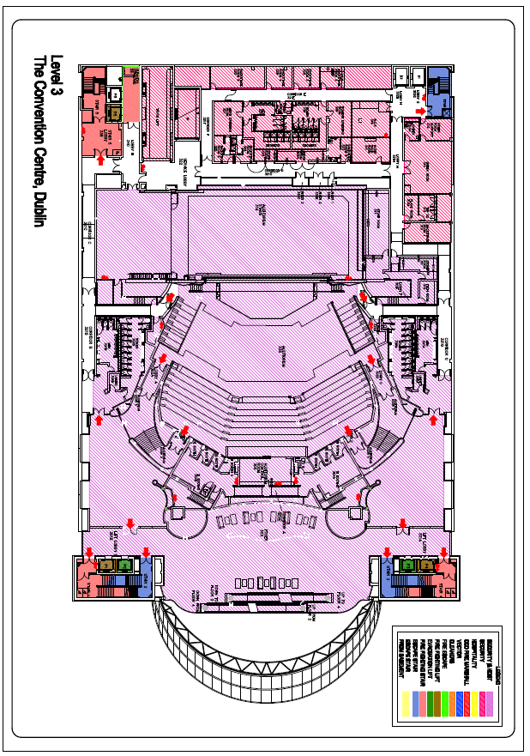

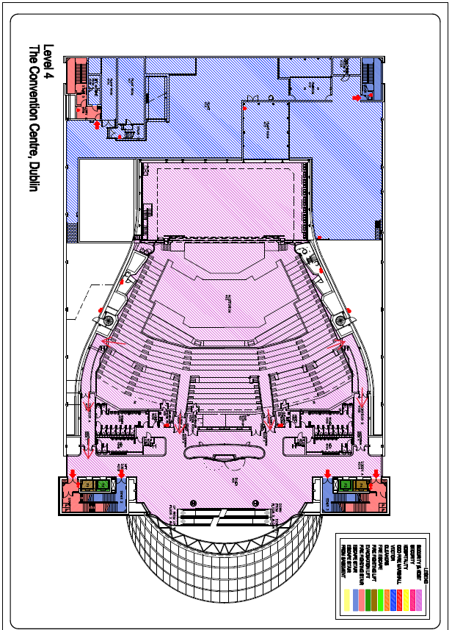
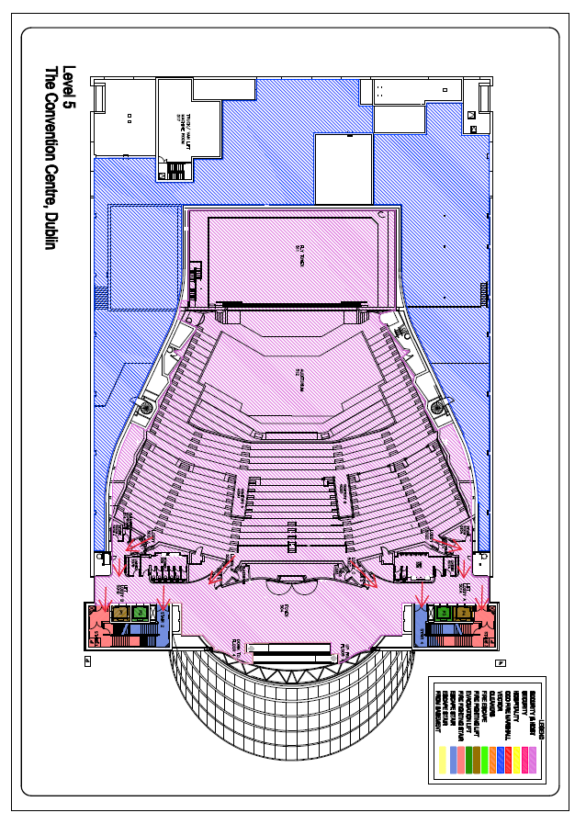

Assembly Fire Point
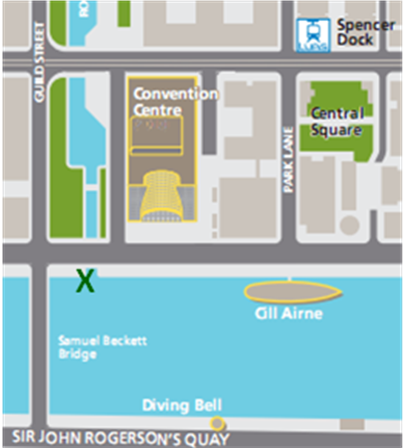
Delegate assembly point

